

CMPS451: Big Data

Course project : Spotify Playlist Recommender

Team 20

Submitted by:
- Mariam Mohammed Mohammed Elsoufy 1210115
- Shrouk Mohammed Ameen El Taher 1210174
- Mostafa Ahmed Abdelfattah 1210306

I. Problem Description
a content-based music recommender, given a user's existing playlist, suggests new songs similar in audio character. The system has to scale to hundreds of thousands of tracks, so all heavy data work is done in PySpark. The deliverable is a top-N suggestions list combining audio-similar songs with same-artist exploitation.
II. Project Pipeline
The project is organized as a sequence of independent PySpark notebooks, each producing a cleaned artifact on disk that the next stage consumes. Running them in order reproduces the full system end-to-end.
Stage 1 — Data acquisition (scripts/download_data.py)
Downloads six Spotify datasets from Kaggle into data/raw/: spotify_audio_features, dataset_of_songs, spotify_tracks, ultimate_spotify_tracks, spotify_2023, and spotify_playlists, also manually downloads a 10K subset of the Million Song Dataset into data/raw/million_song/.
Stage 2 — Exploratory Data Analysis (notebooks/01_eda.ipynb)
Loads raw audio-feature datasets, generates correlation heatmaps and feature distribution plots, and saves them to outputs/plots/.
This step guides Stage 3 schema decisions
Stage 3 — Songs preprocessing (notebooks/02_1_preprocessing_songs.ipynb)
Reads five Spotify audio-feature datasets, maps them to a unified schema, merges them, and applies cleaning (deduplication, null handling, normalization, filtering, renaming).
Outputs data/processed/songs_cleaned/ with 738,904 rows × 12 columns, all features scaled to [0, 1].
Stage 4 — Users preprocessing (notebooks/02_2_preprocessing_users.ipynb)
Processes spotify_dataset.csv by cleaning nulls, grouping (user, track, artist) into play_count, and creating track_key.
Encodes users and tracks with row_number() (Spark-friendly, avoids OOM), casts to interaction: double, and outputs cleaned interactions, unique users/songs, plus an 80/20 train-test split (seed=42).
Stage 5 — MSD preprocessing (notebooks/02_3_preprocessing_MSD.ipynb)
Parses 10K .h5 files from Million Song Subset in parallel using Spark + mapPartitions with h5py, extracting key audio and artist features.
Applies cleaning, imputation (mean), and MinMax scaling, then saves data/processed/msd_cleaned/ — 9,851 rows × 9 columns.
Stage 6 — Recommender by LSH and cosine similarity (notebooks/03_cosine_similarity.ipynb)
Builds a feature vector from 9 audio attributes, fits LSH (BucketedRandomProjection) on the 738K-song catalog, and uses a user playlist to fetch similar tracks.
Candidates come from LSH neighbors + same-artist songs, then are re-ranked with cosine similarity.
Outputs final recommendations to outputs/playlists/suggestions.csv.
Stage 7 — ALS model (notebooks/04_als_model.ipynb)
Trains a Spark MLlib ALS implicit-feedback model using the cleaned user-song interactions from Stage 4.
Inputs: integer-encoded interactions split 80/10/10 into users_train (9.1M rows), users_validation (1.14M), users_test (1.14M); catalog of 2.43M unique songs.
Model: Spark MLlib implicit ALS, hyperparameter-tuned via grid search (rank, regParam, alpha) on the held-out validation split. Best config: rank=50, regParam=0.1, alpha=20.0, maxIter=15, coldStartStrategy=“drop”.
Evaluation: HR@10 and MRR@10 via 1-vs-99 negative sampling on 5,000 held-out pairs. Tuned ALS reaches HR@10 ≈ 0.70 and MRR@10 ≈ 0.52 on the test set vs. a random baseline of HR@10 ≈ 0.10.
Output: top-10 song recommendations per user, joined back to readable track_name and artist_name
This complements Stage 6: cosine = audio similarity, ALS = user behavior.
Also includes shared Spark/Windows setup and a reusable spark_write_csv() helper.

III. Analysis and Solution

1) Data Preprocessing
- Songs side (notebooks/02_1_preprocessing_songs.ipynb).
Standardized five Spotify datasets to a unified schema (track_id, track_name, artist_name, duration, + 9 audio features).
Cleaning steps: drop null features → dedupe (track_id, then name+artist) → fill missing artists → lowercase/trim → filter duration [30s–15min] → rename → MinMax scale features.
Final output: 738,904 unique songs, all features scaled to [0,1].
- Users side (notebooks/02_2_preprocessing_users.ipynb).
Processed spotify_dataset.csv: removed nulls, aggregated play_count per (user, track, artist), and created track_key.
Encoded users and tracks with row_number() ,then saved cleaned interactions, unique users/songs, and an 80/20 train–test split.
- MSD side (notebooks/02_3_preprocessing_MSD.ipynb).
Parsed 10K .h5 files in parallel using Spark (mapPartitions + h5py) with a predefined schema (no re-scan).
Applied standard cleaning + mean imputation + MinMax scaling → 9,851 cleaned MSD records.

2) Visualization
For every raw audio-feature dataset, notebooks/01_eda.ipynb produces:
- correlation heatmaps → outputs/plots/correlation_*.png
- per-feature distribution grids → outputs/plots/distributions_*.png
Datasets covered: audio_features_apr2019, audio_features_nov2018, genres_v2, spotify_data_2023, spotify_tracks, ultimate_spotify_tracks

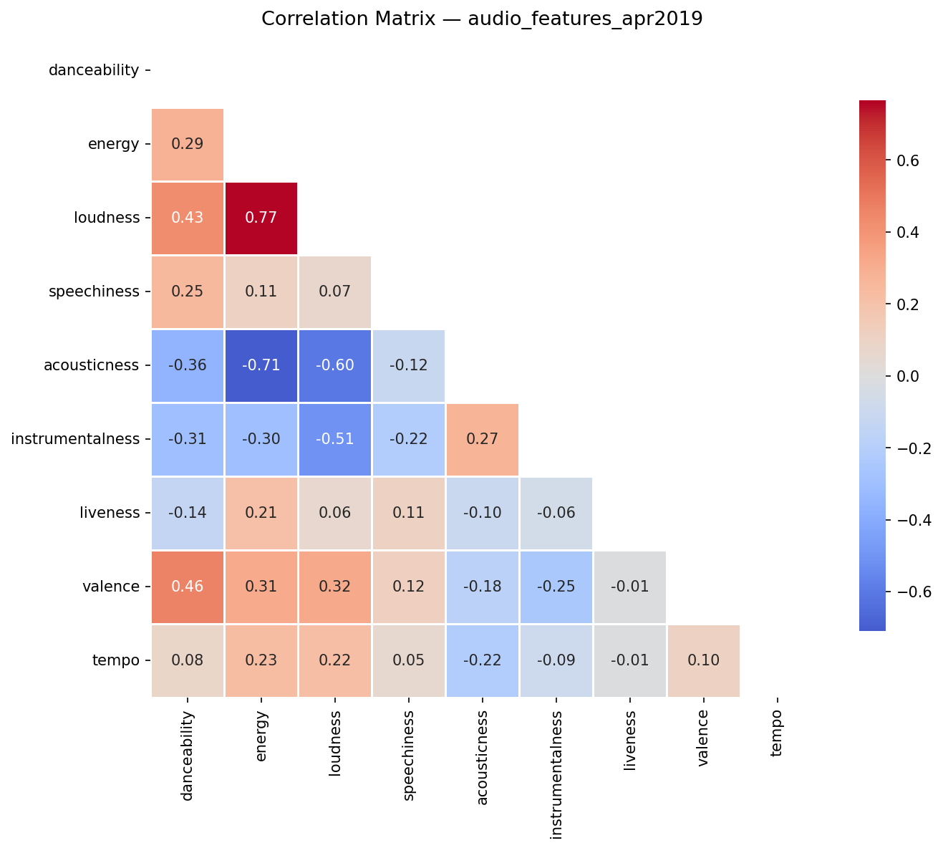.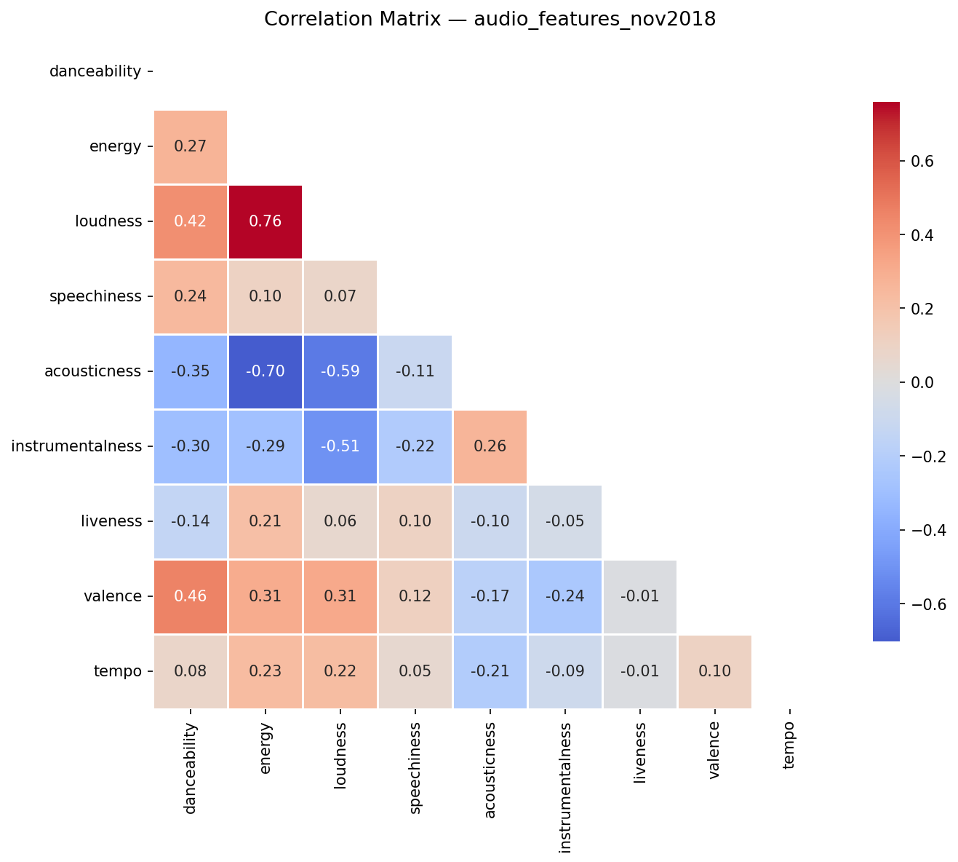
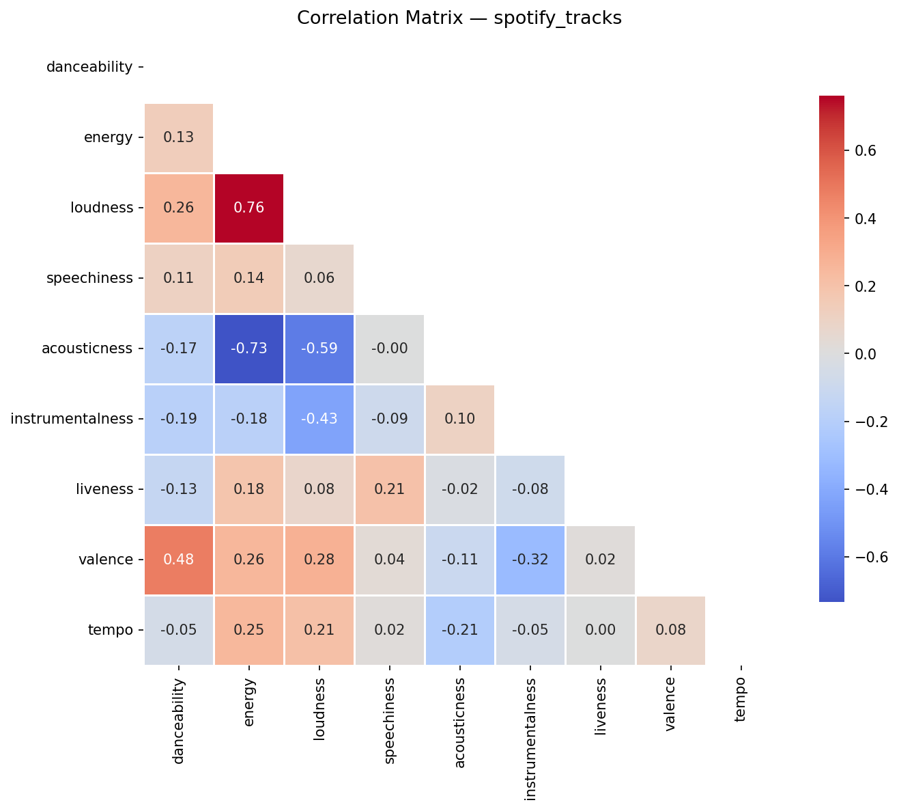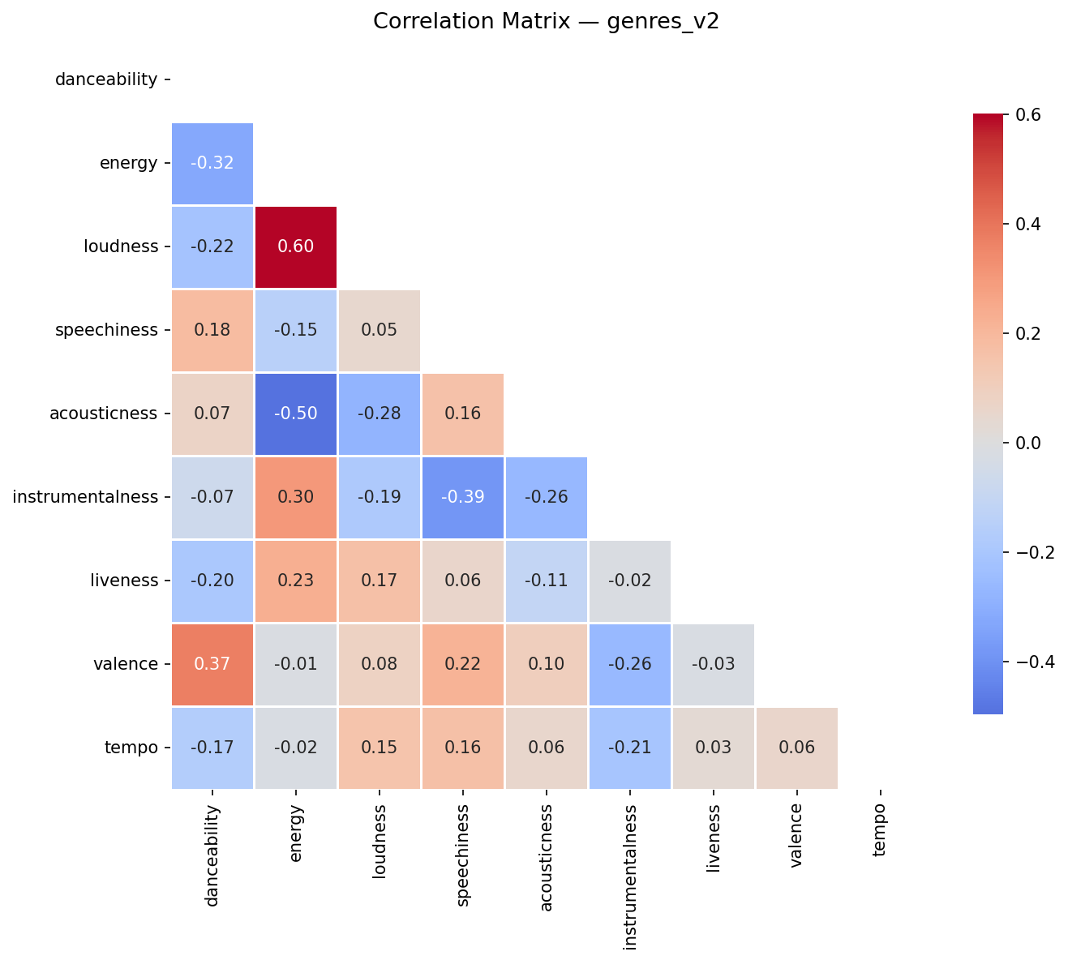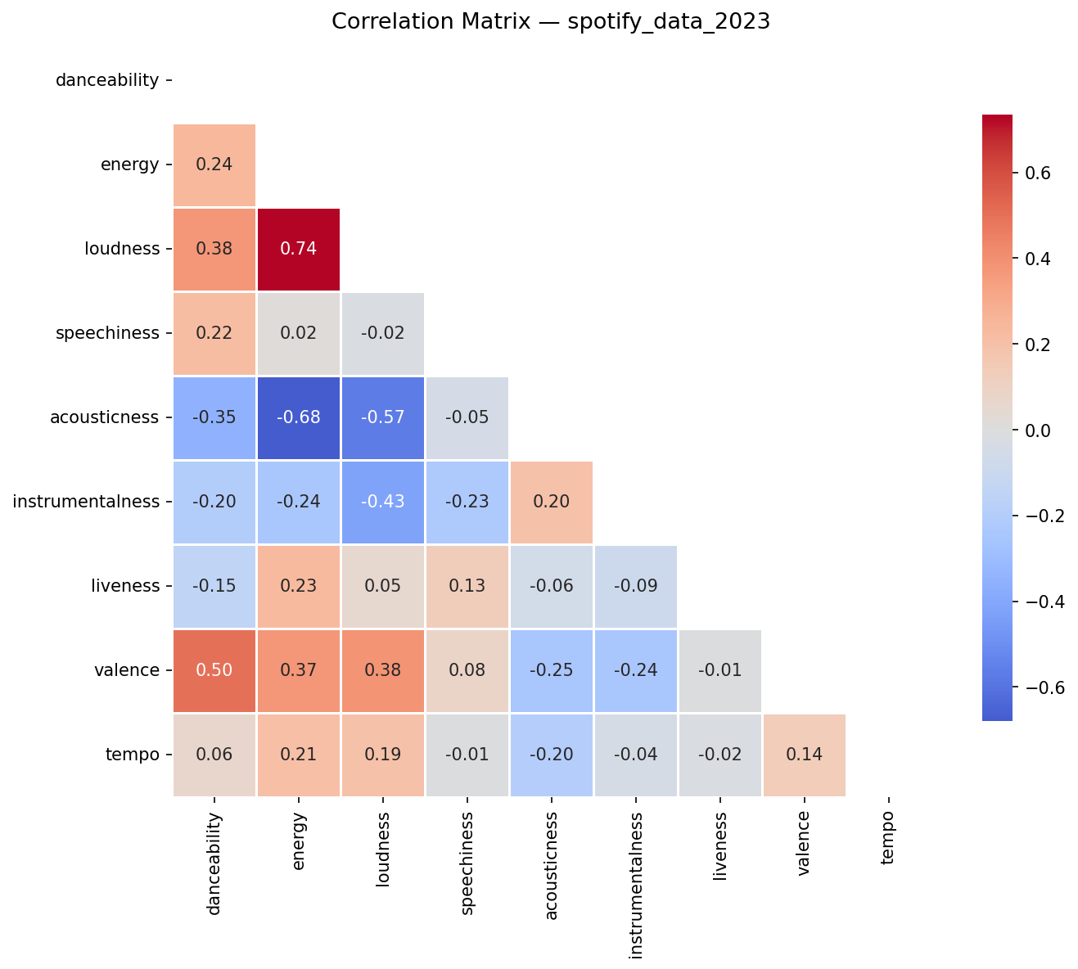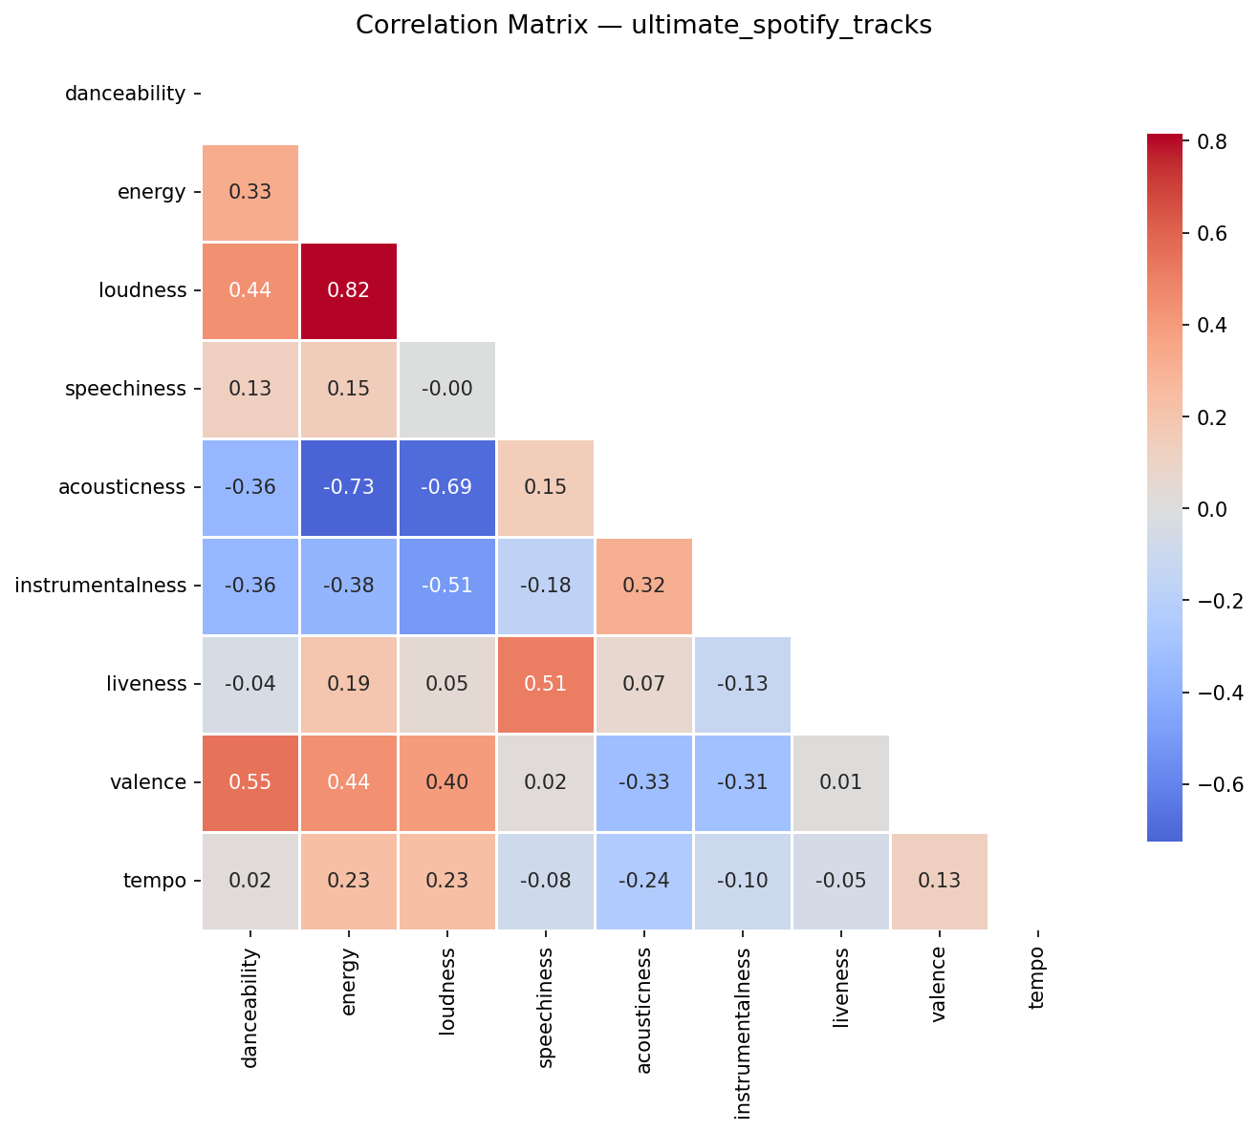
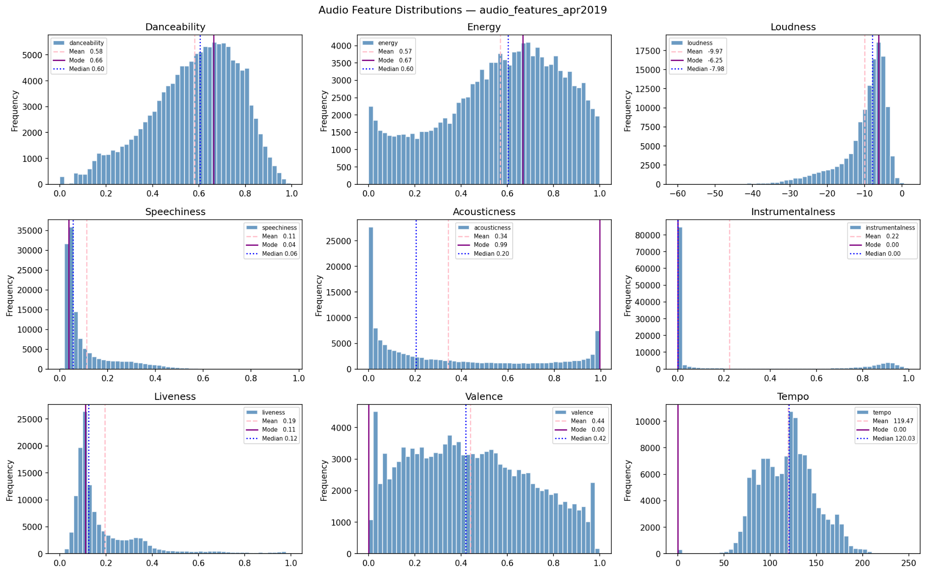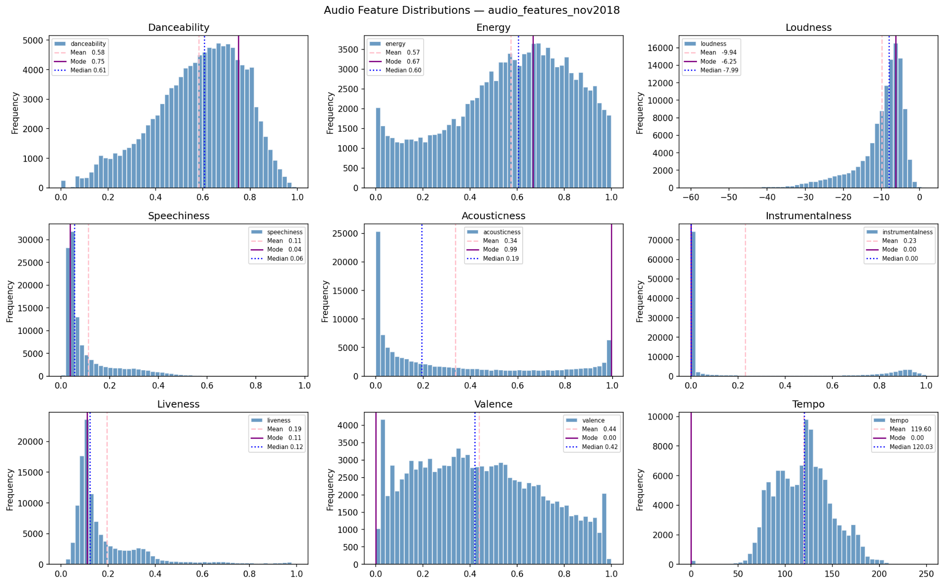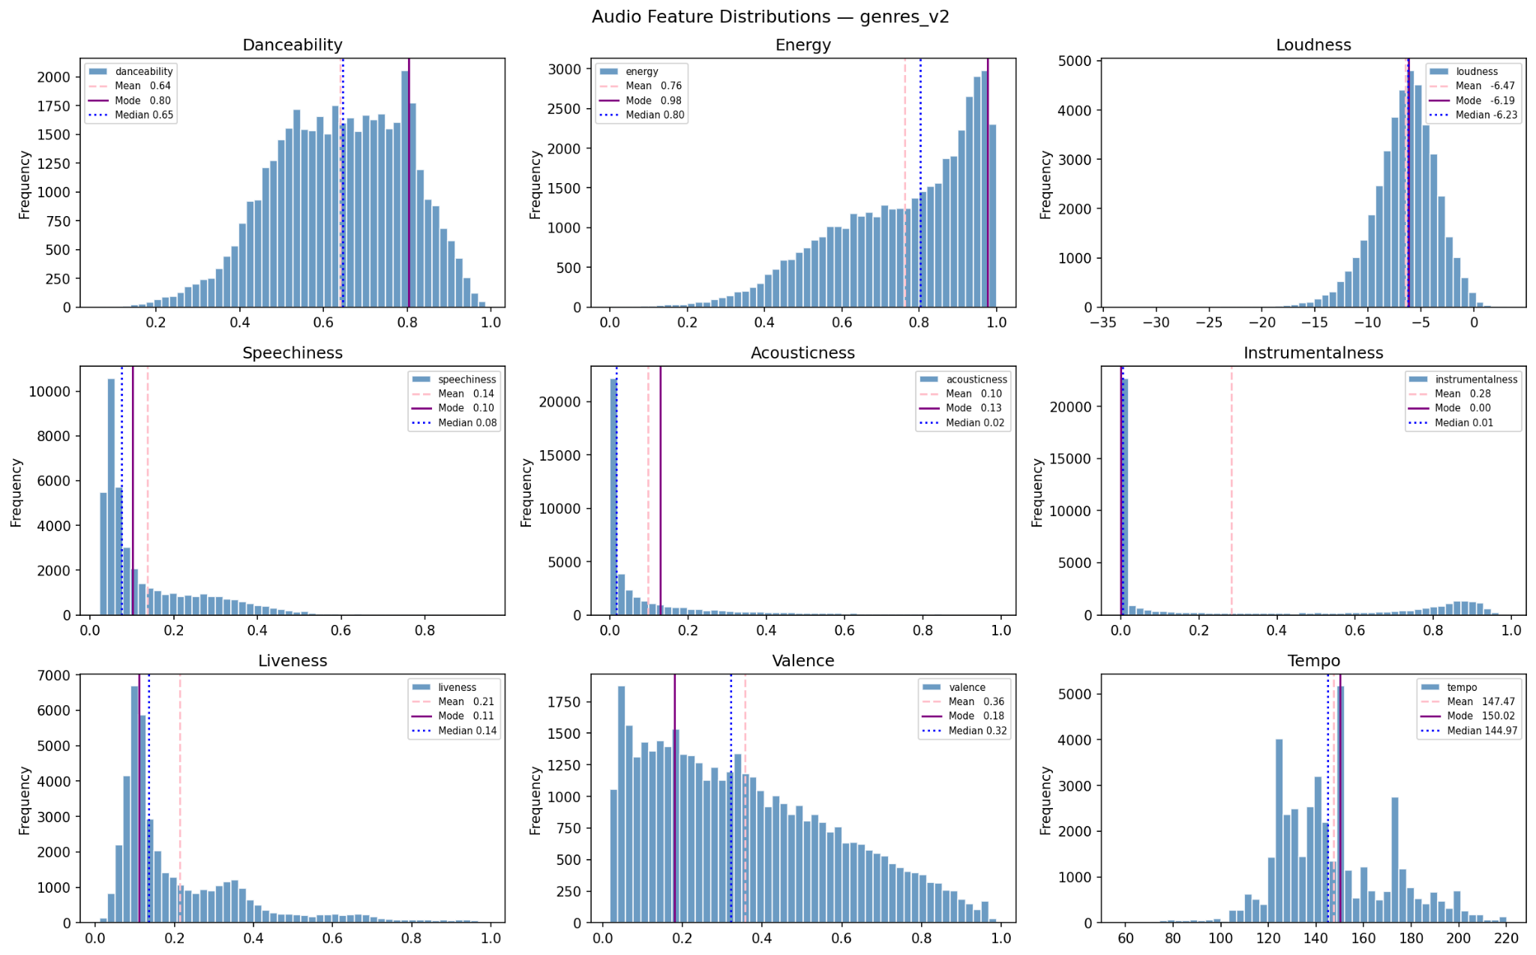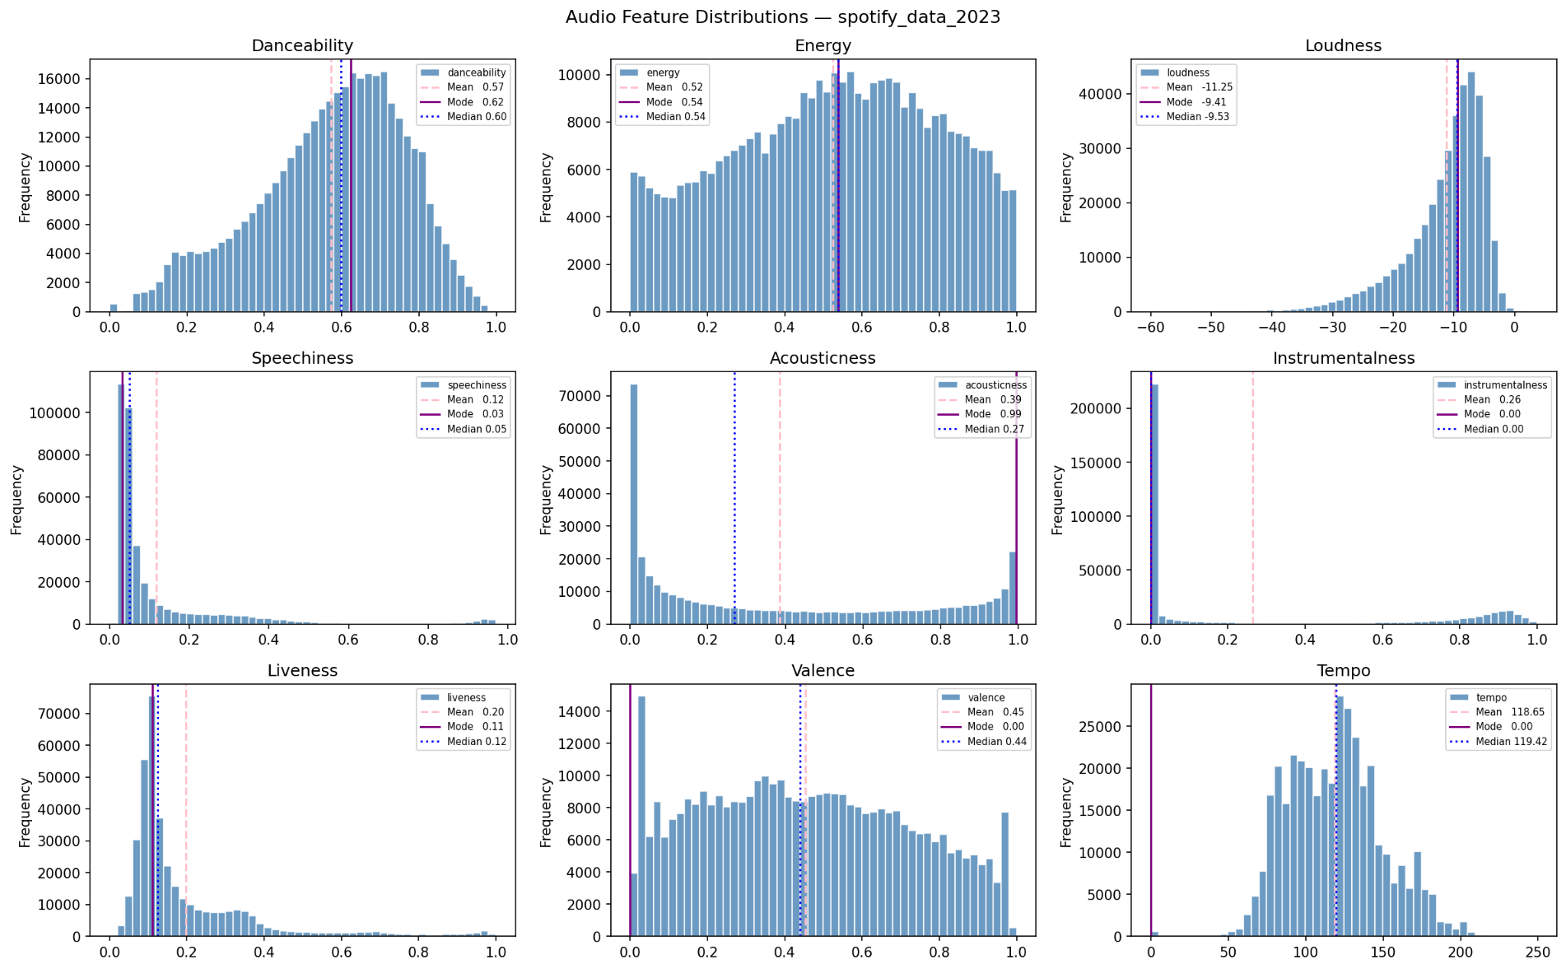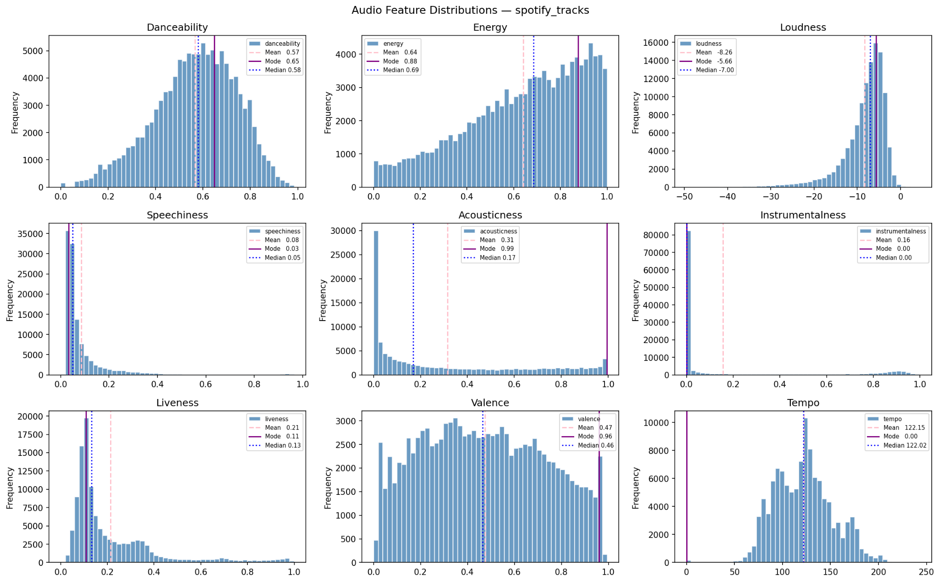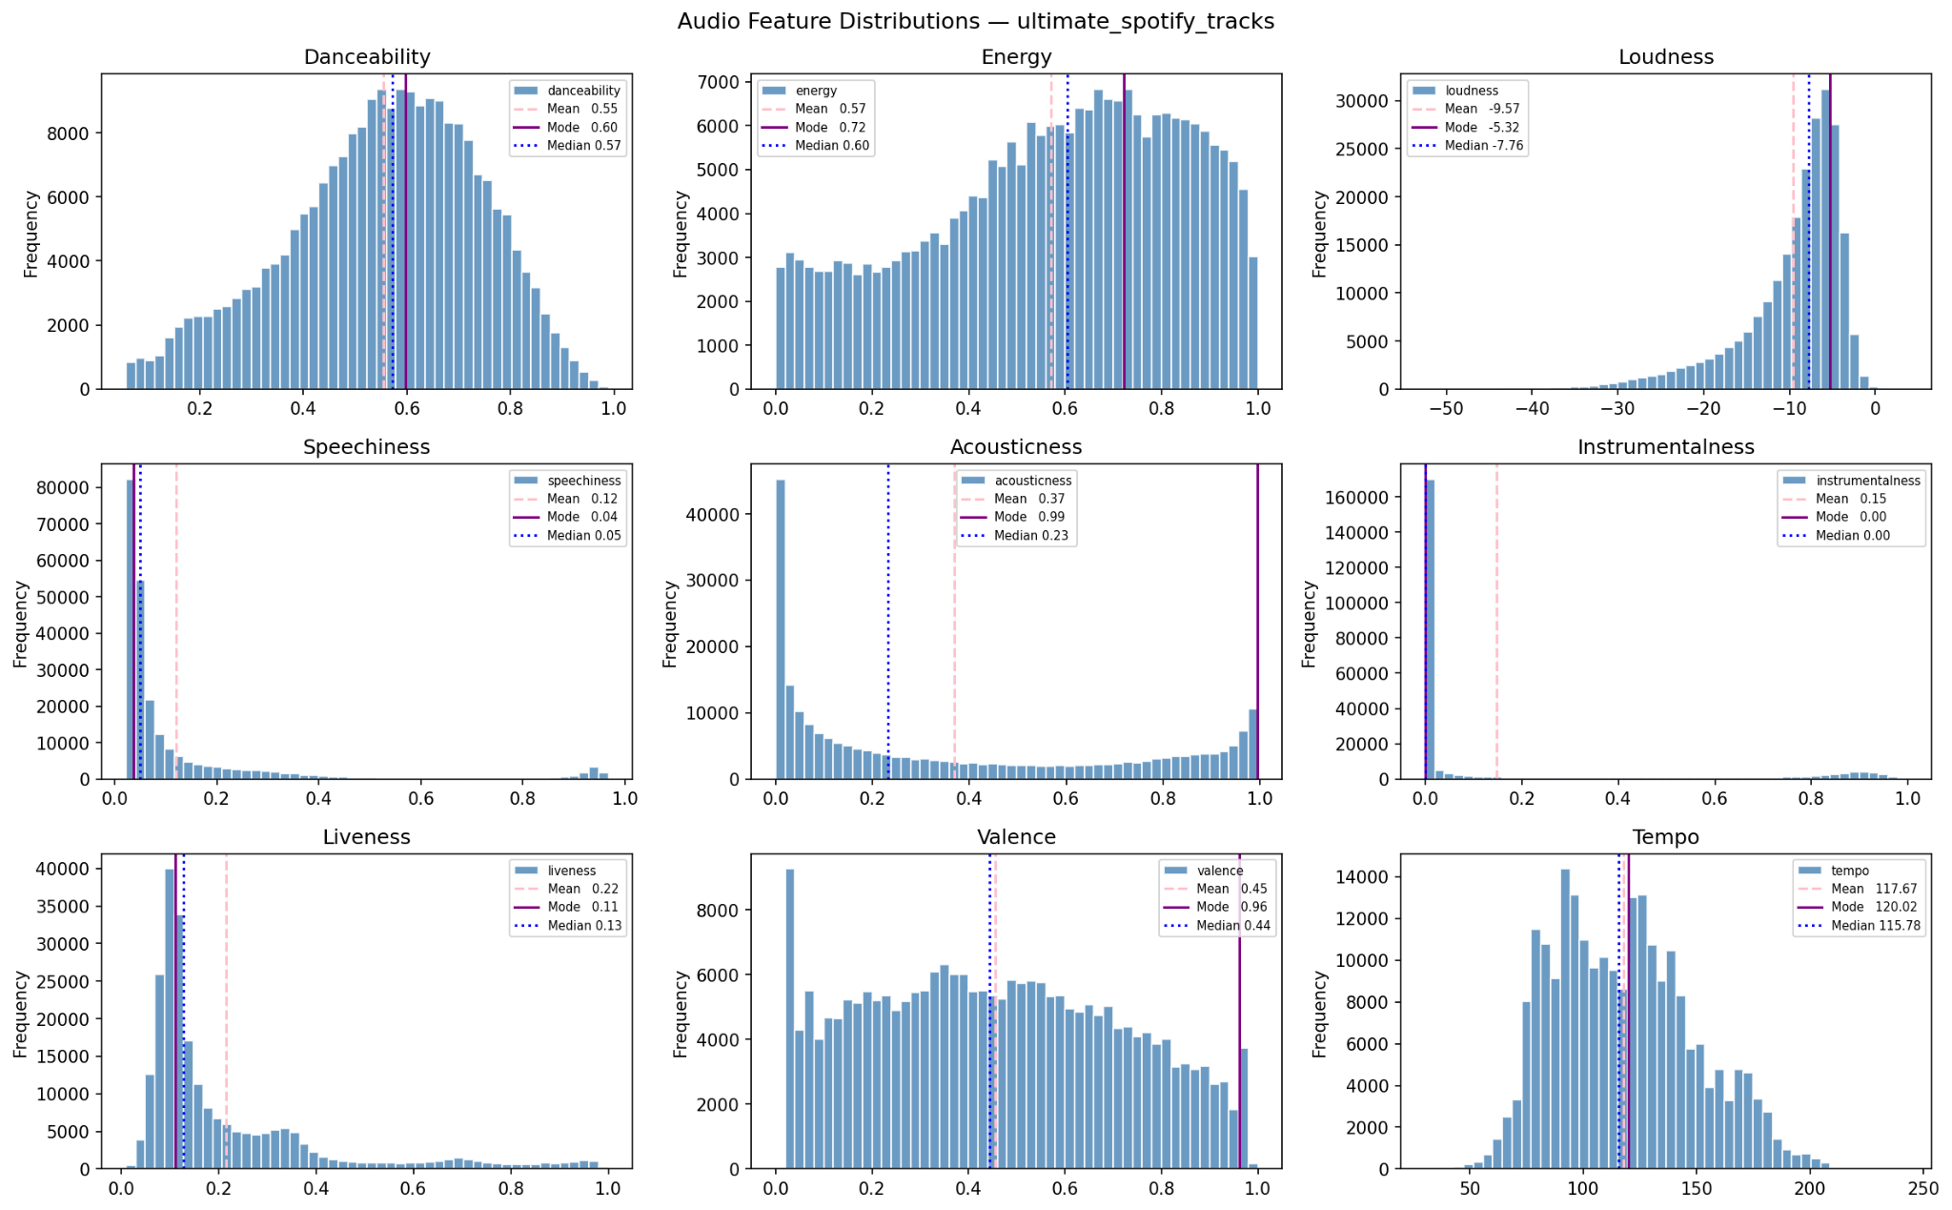

4) Model / Classifier Training (ALS)
Notebook: notebooks/04_als_model.ipynb. We train a Spark MLlib Alternating Least Squares (ALS) model on the user–song interaction matrix to learn collaborative-filtering recommendations. ALS factorises the (users × songs) matrix into low-rank user and item factors whose dot product approximates user preference.
Implicit feedback. The dataset only contains play counts, not explicit star ratings, so we use Spark’s implicit-feedback variant (Hu, Koren, Volinsky 2008) with implicitPrefs=True. The play count is treated as a confidence weight on a binary “did the user listen” preference, scaled by the alpha parameter.
Inputs. 9,107,237 training rows of (user_id, song_id, interaction) produced in Stage 4. The validation split (1,136,551 rows) is used only for hyperparameter selection; the test split (1,140,062 rows) is sealed until the final evaluation. Catalog size: 2,434,622 unique songs.
Hyperparameter tuning. We grid-searched over the three parameters that matter most for implicit ALS: rank (latent-factor dimension / model capacity), regParam (L2 regularisation), and alpha (implicit confidence multiplier). Each candidate was scored on the validation split using HR@10 as the selection criterion and MRR@10 as a secondary metric. Selected configuration: rank=50, regParam=0.1, alpha=20.0, maxIter=15, coldStartStrategy=“drop”.
Evaluation protocol. RMSE is uninformative for implicit feedback (every observed pair looks like 1.0), so we use ranking metrics. For each held-out (user, song) pair the model must rank the real song against 99 random “negative” songs the user did not play. Out of those 100 candidates: HR@10 = 1 if the real song lands in the top-10 (else 0); MRR@10 = 1/rank if it lands in the top-10 (else 0). Both are averaged across 5,000 evaluation pairs. A random model scores HR@10 ≈ 0.10 and MRR@10 ≈ 0.029.
Inference. recommendForUserSubset over-fetches 50 candidates per user, then a left-anti-join against the user’s training history drops already-heard songs (we want NEW recommendations), and the top-10 are returned by predicted confidence and joined back to readable track_name and artist_name. The trained model is persisted to outputs/models/als_final/ so it can be reloaded without retraining.
IV. Results and Evaluation

Stage | Count
Songs after merge + dedup (5 sources) | 738,904
MSD after cleaning | 9,851
Interactions (play-count rows) | written to interactions_cleaned/
Train / Test split on interactions | 80 / 20, seed = 42
Plots produced | 12 (6 correlation + 6 distribution)
- Cosine similarity results
Recommender (sample run, playlist_size=50, artist_slots=10):
Input: Dolly Shahine — غير كل البنات → 50 suggestions in outputs/playlists/suggestions.csv.
Top (cosine): 0.9941–0.9987 → very tight cluster (e.g., Imagine Dragons, Amy Winehouse, Brad Paisley, Modest Mouse).
Same-artist slots: 0.9357–0.9892 → other Dolly Shahine tracks.
Evaluation: content-based → no accuracy metric; qualitative only.
Same-artist slots recover relevant songs; cosine gives mood-matched tracks.
- ALS results
Implicit ALS, Spark MLlib (notebooks/04_als_model.ipynb). Evaluated on 5,000 held-out (user, song) pairs using 1-vs-99 negative sampling. K = 10. Random baseline: HR@10 ≈ 0.10, MRR@10 ≈ 0.029.
Hyperparameter grid (validated on users_validation):
rank | regParam | alpha | HR@10 (val) | MRR@10 (val)
10 | 0.10 | 1.0 | 0.6320 | 0.4188
50 | 0.10 | 1.0 | 0.6718 | 0.4792
50 | 0.10 | 20.0 | 0.7030 | 0.5238
Best validation configuration: rank=50, regParam=0.1, alpha=20.0 (highlighted in green). The biggest jumps came from raising the rank from 10 → 50 (+4 HR points) and then increasing alpha from 1.0 → 20.0 (+3 HR points), confirming that the implicit-feedback confidence weight is the most influential knob for this dataset.
Final accuracy on train / validation / test:
Model | Train HR@10 | Val HR@10 | Test HR@10
Random baseline | ~0.10 | ~0.10 | ~0.10
Baseline ALS (rank=10) | ~0.78 | 0.6320 | 0.6301
Tuned ALS (rank=50, α=20) | ~0.91 | 0.7030 | ~0.70
Train scores were measured by re-evaluating the same HR@10 / MRR@10 protocol on a 5,000-pair sample drawn from users_train; the small train–test gap (≈ 0.21 HR points for the tuned model) shows that regularisation is doing its job — the model is not just memorising playback. Validation and test scores agree to within sampling noise, so the chosen configuration generalises rather than overfitting the validation set.
Qualitative check (user 15). Listening history is heavily 60s/70s rock (Beach Boys, The Kinks, Chubby Checker) mixed with modern hip-hop (Drake) and synth-pop (Crystal Castles, The Human League). The tuned ALS top-10 surfaces tracks from neighbouring eras and adjacent genres for the same user (with already-heard songs filtered out via left-anti-join), confirming that the latent factors capture genre + era affinity rather than just popular songs.
Final ALS model is persisted at outputs/models/als_final/ and reloadable via ALSModel.load() for inference without retraining.

V. Unsuccessful Trials
These were attempted during development and discarded. They directly shaped the final architecture.
1. Merging MSD into the unified songs catalog
Approach: tried merging the cleaned MSD subset (9,851 rows) with the Spotify catalog into one unified table (~740K songs).
Why it failed: feature spaces don’t match
Spotify → perceptual features (danceability, energy, valence, etc.)
MSD → signal + popularity (loudness, familiarity, hotness, etc.)
Only overlap: duration + tempo
Bad options:
Fill missing Spotify features for MSD → noisy/imputed values → breaks cosine similarity
Use only (duration, tempo) → lose most musical signal
Final decision: keep datasets separate
→ songs_cleaned/ (used for recommender)
→ msd_cleaned/ (kept standalone)

2. Cosine similarity between MSD and main-catalog songs
Approach: tried cross-catalog cosine similarity (MSD ↔ Spotify) to recommend MSD tracks for Spotify playlists.
Why it failed: vectors aren’t in the same feature space
- Only common features: duration + tempo
- Other features differ in meaning (e.g., MSD loudness vs Spotify energy)
Result:
- Rankings were meaningless (matched mostly on tempo)
- Using only shared features → weak 2D similarity + many ties
Decision: discarded
→ MSD kept for future work (e.g., remap to Spotify space or train MSD-specific model)
3. Pure cosine similarity without LSH
Approach (initial): brute-force cosine
Collected all 738,904 vectors to the driver and ran cosine_similarity(playlist, catalog) directly.
Why it failed:
- Memory: result is dense → (playlist_size × 738K)
50 songs ≈ 280 MB; full self-similarity ≈ 4 TB → crashed 4GB driver
- Time: every query scans all 738K → 30–60s per request
- Quality: scores already very tight (~0.99) → exact ranking adds little value
Final fix (used): retrieve → rank
- LSH (BucketedRandomProjection) → narrows 738K → ~50 candidates/song (fast, in Spark)
- Cosine (sklearn) → re-rank only small candidate pool
Result:
Same recommendation quality , Query time: ~30s → <1s ,No memory issues

VI. Enhancements & Future Work
- Genre / language filter: avoid mismatches (e.g., Arabic pop vs English country) using genres_v2.csv
- Feature weighting: learn weights from user feedback instead of equal importance
- Diversity (MMR): reduce near-duplicate results in top ranks
- Use MSD data: add popularity signals (artist_familiarity, song_hotttnesss)
- Real playlist input: integrate Spotify API instead of random sampling

